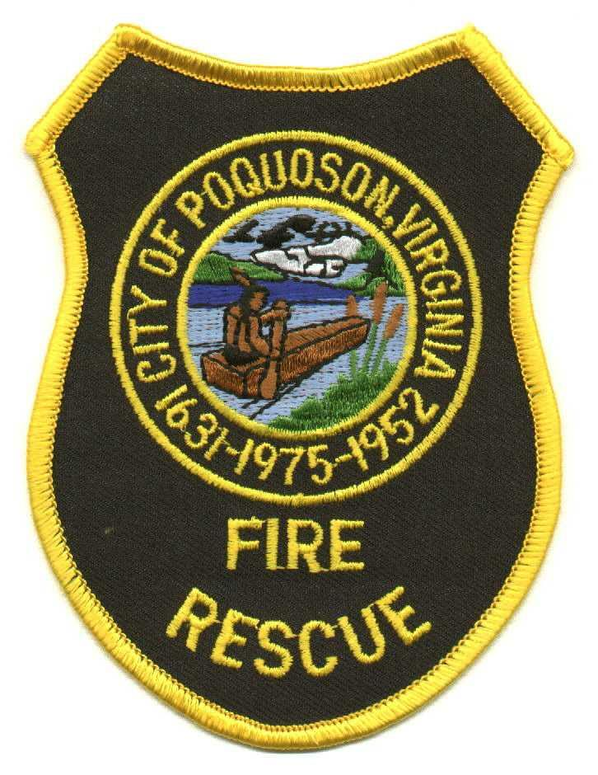

City of Poquoson Fire/Rescue
101 City Hall Avenue, Poquoson, Virginia 23662 (757) 868-3510 Fax (757) 868-3514

Summary

- Date change and formatting changes.

- Renamed to “Extended Leave”

- Simplified policy to cover any employee on approved FML

- Referred to City FMLA policy and Light Duty policy rather than repeating it

